User input implementation:

To change the users name, starting balance or betting amount, the code needs to be changed. To make it easy for users to assign these values, I implemented user input.

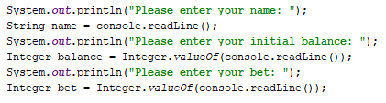

This is in the Main.java class before the while loop of the game.

The output is the following:

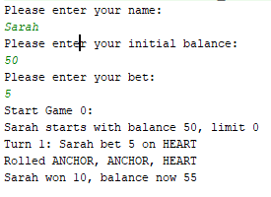

I came across this idea when I saw this line in the code:



Which indicates there will be a user input somewhere in the code but I did not find one hence I created the above.